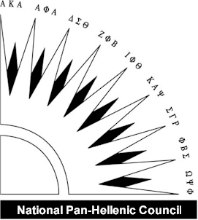
National Pan-Hellenic Council of NIU
Yard Brick Order Form

Name:_____________________________________________________
Address:___________________________________________________
City____________________ State________ Zip Code:______________
Phone (____)____-_______ Email: _____________________________
Please circle the size of brick you would like to order:
Brick Prices: 6”x8”- 4 lines of 12 Characters- Sells for $100
6”x12”- 4 lines of 16 Characters- Sells for $150
12”x12” 4 lines of 16 Characters- Sells for $500
*Please note, these prices are only available for Homecoming Weekend. Prices will increase after this weekend.
Text to be included on brick (Please print one character per box. Please note: spaces count as one character):
1 | 2 | 3 | 4 | 5 | 6 | 7 | 8 | 9 | 10 | 11 | 12 | 13 | 14 | 15 | 16
Please make all checks payable to Northern Illinois University.

Thank you for helping to contribute to the yard of the National Pan-Hellenic Council at Northern Illinois University.

