Webprint - Changing Output Options at the Printer
1. To release print jobs, select Print Release to see your print jobs in the queue.
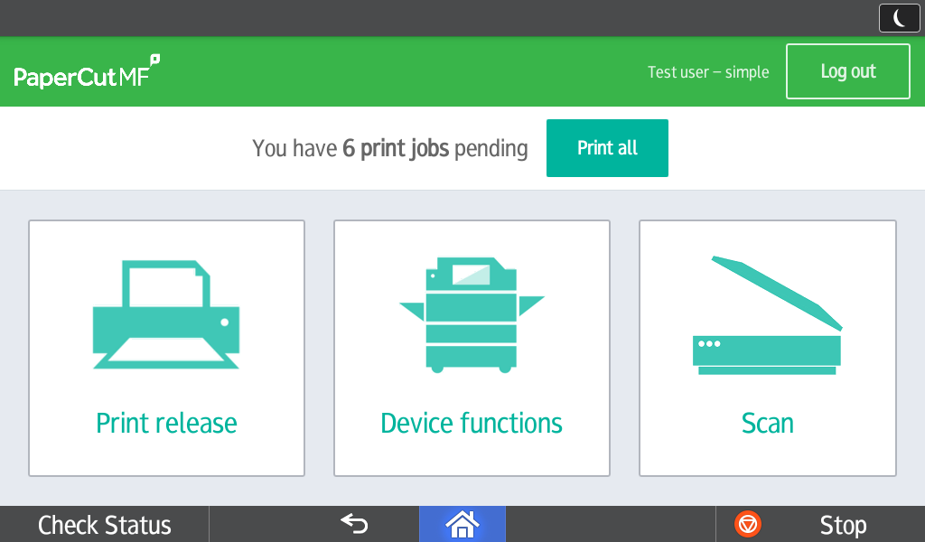
2. Managing individual print jobs:
A. On the bottom bar of the screen:
Select the checkbox to force greyscale mode and/or 2-sided print
You may choose to delete or print selected job(s)
.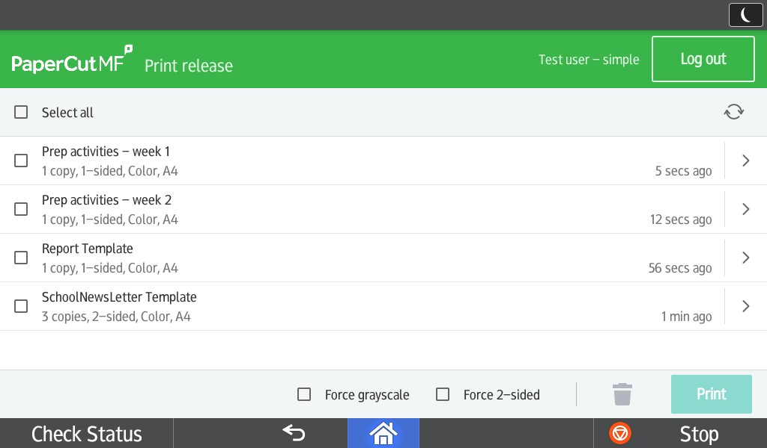
3. Pressing the arrow to the right will take you to the print job details
A. Here you can change:
The number of copies,
1-sided or 2-sided print,
Color to Grayscale (B/W)

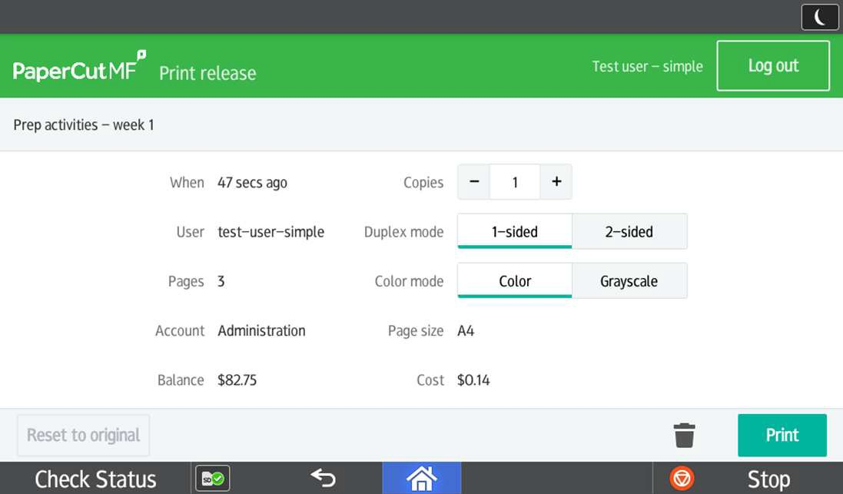

Note: You cannot change a print job that was sent as b/w into a color job
Note: When changing a color job to grayscale (b/w) the cost will adjust accordingly

