OFFICE OF RESEARCH COMPLIANCE,
INTEGRITY AND SAFETY
ANNUAL REPORT 2020

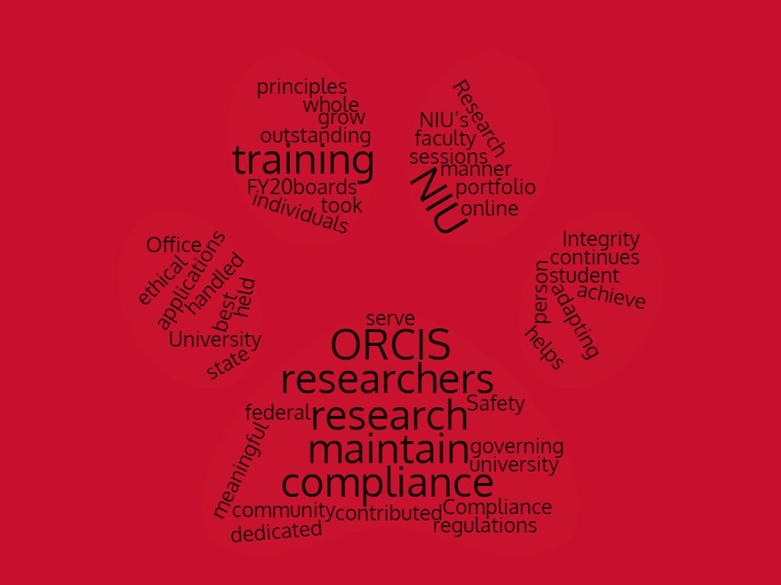

Table of Contents
About ORCIS 4
Compliance 5
Human Research 6
Applications 6
Training 7
Electronic Submissions 8
Covid-19 Efforts 8
Payment Updates 8
Professional Development 8
Animal Research 9
Applications 9
Inspections 9
Reporting 9
Training 10
Covid-19 Efforts 10
FOIA Assistance 10
Research Integrity 11
Export Control 11
Data Management 12
Foreign Influence 12
Conflicts of Interest 12
Responsible Conduct of Research 13
Research Misconduct 14
Covid-19 Efforts 15
Professional Development 15
Safety 16
Laboratory Safety 16
Laboratory Safety Committee 16
Training 17
Waste Disposal 18
Health and Safety Policy 18
Institutional Biosafety Committee 18
Radiation Safety 18
Laser Safety Committee 18
Internal Inspections 19
External Inspections 19
Covid-19 Efforts 19
Electronic Storage 19
Professional Development 19
Outreach 19
Conclusion and Outlook 20

Office of Research Compliance, Integrity, and Safety

The Office of Research Compliance, Integrity, and Safety (ORCIS) at NIU helps researchers and the University as a whole, achieve and maintain ethical principles and maintain compliance with federal, state and university regulations governing research. In FY20 ORCIS contributed to the NIU community in a meaningful and dedicated manner. The compliance boards handled 1035 applications, 62 in person training sessions were held, and over 1331 individuals took online training. As NIU’s research portfolio continues to grow ORCIS is adapting to best serve our outstanding faculty and student researchers.

COMPLIANCE

Compliance aspects of ORCIS are managed by Dr. Patricia Wallace, the Research Compliance Coordinator, and Lene Scherer, the Research Compliance Analyst. The two work together and are primarily responsible for human subjects research and animal research. Biosafety research falls into the compliance category as well but will be addressed in the safety portion of this report.
HUMAN SUBJECTS RESEARCH
APPLICATIONS
In FY20, the Compliance group assisted with 939 unique submissions to the Institutional Review Board (IRB), which deals with human subjects research. Of these, 369 were considered initial submissions, 206 were continuations of existing records, 213 were amendments to existing records, and 151 were final reports (to close a protocol record). The breakdown is as follows:

- Initial Submissions (New proposals)
  - Exempt: 162
  - Expedited: 153
  - Full Board: 13
  - Collaborative Agreements: 9
  - Screening Forms: 32
- Continuation Submissions (Proposals that require additional time)
  - Administrative Review: 185
  - Member Review: 10
  - Full Board Review: 11
- Amendment Submissions (Proposals with changes)
  - Administrative Review: 96
  - Member Review: 112
  - Full Board Review: 5
The applicants are a mixture of faculty, graduate students, and undergraduate students. Every submission is analyzed and sorted into the proper review category by the staff. Notices of expiration dates and required renewals are also monitored and sent out.

TRAINING
In FY20 the compliance office offered approximately 28 training sessions.

The breakdown is as follows:
- Authorized Departmental Reviewer (ADR) trainings
  - General sessions: 4
  - Individual sessions: 10
  - Department Sessions: 2
  - Total trained: Approximate 100
- In-Person in class trainings:
  - Classroom trainings: 6
  - Total trained: Approximate 120
- Online custom presentations:
  - Virtual classes: 4
  - Total trained: Approximate 100
- New IRB Member trainings: 2
- Citi Online trainings:
  - IRB Member refresher: 38
  - Initial IRB training: 966

ELECTRONIC SUBMISSIONS
In FY20 the Compliance Coordinator moved the IRB application process to an online system. This included creating all the electronic forms, testing the system, transferring large scale current protocols, and creating and providing trainings and training materials for applicants and departmental reviewers. This was a time-consuming major effort that will benefit and streamline the application process for both ORCIS and the NIU community members who utilize the IRB.

COVID-19 EFFORTS
Due to the pandemic, all face-to-face research was stopped. The Compliance team created guidance for the transition of face-to-face research to online research. When restrictions were lifted, they also provided guidance on resuming protocols and an online application for that process. Although most of these applications were submitted in FY21, there was one such application in FY20. The Compliance team also created and distributed the results of a research project based on a survey assessing the effects that COVID had on researchers at NIU. This information has been valuable and utilized by other offices, with four responses from others, including the office of federal relations, and requesting additional information or a presentation of the findings at a meeting.

PAYMENT UPDATES
ORCIS also began the process of updating policy regarding research participant payments in FY20. The first draft of the policy was created, and discussions began in spring with the goal of an FY21 implementation.

PROFESSIONAL DEVELOPMENT
In FY20 the Compliance Coordinator attended the Annual PRIM&R Social, Behavioral, and Educational Research Conference and Advancing Ethical Research Conference in Boston, MA (Nov 2019). The Compliance Coordinator is also working towards their Certified IRB Professional Certificate, with testing in FY21.

ANIMAL RESEARCH
APPLICATIONS
ORCIS houses the Institutional Animal Care and Use Committee (IACUC) which approves animal research preformed at NIU. This year the IACUC saw 59 new applications.
The breakdown is as follows:
- Initial Applications: 5
- Continuations: 22
- Triennials: 7
- Amendments: 11
- Final Reports: 14
Applicants are mainly faculty members. NIU has two animal laboratories where most of this research is preformed; however, ten of the protocols are for field animal research. ORCIS analyzes and processes every application. They also provided notice of all expirations and required renewals.
INSPECTIONS
The USDA preforms one un-scheduled inspection yearly. ORCIS assists the inspector by providing all of the files, touring the facilities, and answering questions. The IACUC also preforms two semi-annual inspections.
REPORTING
ORCIS is responsible for all required animal reporting, this includes filing papers with the DEA, USDA, FDA, and our OLAW assurance.

TRAINING
In FY20 ORCIS offered one in person animal training session for the members of the IACUC. Researchers are expected to participate in online Citi Training. The breakdown is as follows:
- IACUC annual member training: Eight
- Online Citi trainings completed: 64
COVID-19 EFFORTS
ORCIS assisted the animal caretakers with handling laboratory closures during shelter-in-place. The process utilized for reopening of facilities is addressed in the Safety Section.
FOIA ASSISTANCE
NIU received four FOIA requests involving animal research, most were for records that ORCIS houses. We worked with General Counsel, the researchers, and the FOIA department at NIU to respond to these requests as required by law.

RESEARCH INTEGRITY
ORCIS responsibilities for research integrity involves several different topics. ORCIS responsibilities evolve as new requirements regarding research arise from the federal government and other agencies. Shannon Stoker, Director of ORCIS, is responsible for research integrity policies and policy implementation.
EXPORT CONTROL
Federal export control regulations pertain to the export, transfer or transmission of certain commodities, software, technology and technical information from the United States to foreign destinations or to foreign nationals on U.S. soil.
Ensuring compliance involves several activities, including screening individuals against denied parties lists, assisting faculty and staff who wish to travel abroad specifically if they carry NIU property, and assessing situations involving federal funding and nationalities.
In FY20:

- A total of 1114 people and companies were screened against Restricted Parties Lists, although escalation review and administration lies with ORCIS the screening is a joint effort between ORCIS, SPA, and Procurement.
- Approximately 500 people and companies were screened against Restricted Parties Lists in an ad-hoc scenario. (Partner screening occurs daily; Ad hoc screening occurs once.)
- A total of 86 travel applications were assessed for export control concerns
- Only four funding opportunities involved an export control assessment
- To assist faculty and students traveling abroad a loaner laptop program was developed in FY20 to protect NIU from possible theft of controlled information and/or technology.
DATA MANAGEMENT
The sharing of data between organizations calls for an agreement between parties. These agreements are screened by ORCIS and signed by the VP Research. Six agreements were screened in FY20.

CONFLICTS OF INTEREST
Institutions receiving Public Health Services (PHS) funding must monitor their Principal Investigators for possible Conflicts of Interest through a proactive policy. In FY20 ORCIS received six disclosures from six PHS funded projects. The training is required every four years and ORCIS offers this training through the CITI online modules. In FY20, 32 individuals took the training. ORCIS would like to expand the COI reporting to all staff and faculty disclosing and in FY20 began working with General Counsel and the Provost’s Office to make this a reality and better protect the university.

FOREIGN INFLUENCE
The federal government has a growing concern for foreign influence and theft of intellectual property by foreign states. The government has requested universities take a proactive role in combating this threat. In FY20 ORCIS developed a website on the topic, gave three trainings to faculty and staff, attended two in person sessions to discuss ways to manage the issue, and instituted a disclosure for all NIU employees applying for any funded research. ORCIS is continuing to develop programs to educate the NIU community on the threat of foreign influence and is active in implementing government guidance. ORCIS represents NIU on the Academic Security & Counter Exploitation Program and has strong FY21 goals for combating foreign threats to our scholarly activities.

RESPONSIBLE CONDUCT OF RESEARCH
ORCIS is responsible for monitoring and providing training in the Responsible Conduct of Research (RCR). This service is provided two different ways. The first is traditional trainings direct from ORCIS. This includes mandated trainings by students who receive funding from NSF grants. In FY20, two graduate students required RCR training and both completed the course.

The training comprises:
- In Person:
  - Classroom sessions:
    - One session for Graduate Professionalism involving approximately 20 individuals
    - Four sessions for Graduate Ethics Chemistry involving approximately 60 individuals
- Online:
  - Citi – 132 Individuals

The second way ORCIS provides RCR training is in conjunction with the Graduate School. Both offices work together to provide a forum series, opened to all but geared toward graduate students. In FY20, ten training sessions were offered.

The training topics and individuals served follow:
- Mentoring – 25 attendees
- Collaborative Research – 19 attendees
- Animal Care and Use - 6 attendees
- Conflicts of Interest - 15 attendees
- Peer Review – 26 attendees
- Authorship and Publication - 14 attendees
- Research Misconduct - 10 attendees
- Data Management – 8 attendees
Additional attendees may have been present, but their attendance is not counted if they are not participating. Attendance (and participation) at the six core topics over the course of two years earns a graduate student transcript notation. The first transcript notation was awarded in FY20.

RESEARCH MISCONDUCT
NIU strives for the highest level of research integrity. As mandated by the Federal Office of Research Integrity, NIU has a Research Integrity Officer which is fulfilled by Shannon Stoker. In FY20 there were no allegations of research misconduct. While this number should be celebrated, it is still a requirement ORCIS stay up to date on rules and regulations regarding research misconduct so NIU is prepared for any allegation. Time was devoted to ensuring policies and procedures are active and compliant with Federal regulations. NIU is an active member in the Association of Research Integrity Officers.
COVID-19 EFFORTS
ORCIS worked with the Office of the Vice President to inventory of all Personal Protective Equipment on campus. This was provided to the State of Illinois. The inventory was later distributed among internal and external agencies based on need. ORCIS also assisted with determining whether NIU could serve as a testing center for COVID or provide viral testing media.
PROFESSIONAL DEVELOPMENT
Attended the Society of Research Associates International national conference in September 2019
Attended the Federal Bureau of Investigation roundtable on Foreign Influence in September 2019
Attended the Federal Bureau of Investigation summit on Foreign Influence in July 2019

SAFETY
LABORATORY SAFETY
NIU has two hundred and twenty teaching and research laboratories on the DeKalb campus. The laboratory safety team includes the Laboratory Safety Manager, Michele Crase, and the Laboratory Safety Officer, Jim Gable. Laboratory Safety includes chemical, biological, radiological and physical hazards present in the laboratory or field research. Various committees oversee portions of laboratory safety. Federal and State regulations require specific committees focus on specific hazards.
LABORATORY SAFETY COMMITTEE
ORCIS houses the Laboratory Safety Committee (LSC). The committee comprises representatives from the administration, staff, and faculty. The LSC implement policies and procedures related to laboratory safety. The group met six times in FY20 and finalized one new policy, the Personal Protective Equipment policy. The LSC is responsible for reviewing and developing recommendations for accidents, in FY20 there was one minor accident reviewed. The LSC also hears requests related to safety in the laboratory, in FY20 there was one, concerning 3D printers in Engineering. Capital Improvement related to safety were also heard and evaluated by the LSC. In FY20, 36 projects were analyzed. However due to budgetary constraints these projects remain inactive.

TRAINING
For general laboratory safety the training breakdowns as follows:

In-person trainings offered:
Department Sessions: 5 sessions
- Biology: approximately 80 individuals
- Chemistry: approximately 50 individuals
- Physics: approximately 40 individuals
- Engineering: approximately 60 individuals
- Psychology: approximately 10 individuals
Classrooms:
- Chemistry (4 classes per year): approximately 80 individuals
- Engineering (4 classes per year): approximately 80 individuals
Online Trainings:
- Citi: 99

Most of these trainings are for a mixture of faculty, graduate, and undergraduate students. Topic specific training follows:
- Building Service Workers Lab safety awareness, online with 240 attendees
- Bloodborne Pathogen for Physical Therapy and Audiology Student, in person with approximately 60 attendees
- Radiation Safety Initial Training in person with approximately ten attendees and online with 50 attendees.
The approximate breakdown of individuals trained includes:
- In person: 450
- Online: 389

WASTE DISPOSAL
18In FY20, ORCIS overhauled the policy for waste disposal to follow the requirement for an Academic Laboratory Rule Subpart K Institution. The conversion involved developing a laboratory safety plan, new training and container labeling, and filing the change with the state. In FY20 ORCIS completed the following disposals:
Hazardous Waste: 6700 pounds
Nonhazardous Waste: 6900 pounds
HEALTH AND SAFETY POLICY
In FY19 the President enacted a Health and Safety policy, demonstrating a commitment to a safe work environment. In FY20 ORCIS worked toward implementation of this policy by meeting with Engineering, Chemistry, Physics, and Anthropology to ensure that they were compliant with the policy. We reviewed their current safety protocols and addressed areas of improvement. This program was cut short but will resume when campus is at capacity.
INSTITUTIONAL BIOSAFETY COMMITTEE (IBC)
While a portion of Compliance, the IBC is managed by the Laboratory Safety Manager. The Committee must review all research that uses recombinant DNA, any infectious substance, select biologic agents, human blood, bodily fluids, or any known biohazard. In FY20 the IBC saw 37 interactions as follows:
- Initial Applications: 2
- Continuations: 21
- Triennial reviews: 12
- Close outs: 2
This committee is mandatory to perform this research at NIU.
RADIATION SAFETY
NIU research utilizes radioactive materials and x-ray machines. This requires compliance with the state regulatory agency Illinois Emergency Management Agency (IEMA). ORICS is also responsible for monitoring and testing instruments. In FY20 the following radiation safety actions were taken:
- Leak testing: 16 radioactive sources tested
- Irradiator Alarm testing: Quarterly alarm tests
- Laboratory Radiation: 32 Surveys
- Instrument Collaboration: 17 instruments
- Radiation safety dosimeter badges and rings: 27 people monitored
- Badges and rings utilized: 216
Radiation Safety also involved The Radiation Safety Committee (RSC) who approves applications for research involving radiation. Applications are reviewed every two years. Currently, six researchers are authorized to use radioactive material in their research. X-ray machines - 9 x-ray machines are monitored for state regulatory compliance.
LASER SAFETY COMMITTEE
There is some research done involving lasers at NIU. The Laser Safety Committee meets each semester to review laser usage. The lasers are inspected by representatives of the committee annually. Currently nine class 3B or class 4 lasers are monitored for state regulatory compliance.
INTERNAL INSPECTIONS
In FY20 the Lab Safety Officer inspected 125 labs. These include labs in Biology, Chemistry Engineering, and Geology. They found approximately 200 violations, of which over 90% were addressed and fixed. Due to the shutdown departments such as Anthropology, Clinical Lab Sciences, and Physics were not inspected as scheduled. They are on the schedule for FY21.
EXTERNAL INSPECTIONS
Lab Safety assists with federal and state inspections, both announced and unannounced. In FY20 there were two inspections, one performed by the Illinois EPA and one by IEMA. There was a violation found with the IEPA which was addressed by our change in waste disposal policy update to subpart K.
COVID-19 EFFORTS
Every laboratory closed during the Phase One order by the governor. To reopen these labs, every researcher had to apply through Lab Safety’s electronic record system. ORCIS worked with other RIPS offices to bring this online quickly and efficiently.
The announcement on lab reopening was made May 14th, 2020, currently 99 laboratories have been approved for opening. (Note, the approval came from the Chairs and Deans, however ORCIS assisted with the application process). As part of reopening labs during the pandemic, ORCIS created an online training available for all laboratory personnel. A total of 60 people completed the training. ORCIS expects this number to increase when graduate students return in the fall.
ELECTRONIC STORAGE
ORCIS developed a method of housing laboratory storage records in InfoEd. This was utilized for the COVID 19 reopening as noted above and will be further developed into FY21.
PROFESSIONAL DEVELOPMENT
Attended Annual Campus Safety, Health, and Environmental Management Association Meeting (Indianapolis). Attended training and certification for shipping dangerous goods such as chemicals and biologics.
OUTREACH
Beyond the responsibilities enumerated above, ORCIS is also a presence of campus. In FY20 Dr. Wallace taught three adjunct psychology courses, Ms. Crase instructed a graduate course on safety, and Ms. Stoker instructed a UNIV 101 course aimed at students interested in attending law school. Dr. Wallace and Ms. Stoker also served on the President’s Council on the Status of Women and Dr. Wallace served as the chair of the ORCIS Director search.

CONCLUSION AND OUTLOOK

ORCIS assists the NIU research community in a wide variety of ways. As a small office with large responsibilities ORCIS is cross trained and assists each other often. Everything accomplished in FY20 has been a team effort.
ORCIS’ goal is always to support research and ensure NIU is compliant with all state and federal regulations. In FY21 the office hopes to strengthen their online presence, including logging all laboratory inspections in Info Ed, update the Conflict of Interest policy campus wide, increase their presence so faculty is aware they are available to speak at online classes, and foster a culture of safety, especially during the current pandemic.

