Northern Illinois University Campus Sustainability Survey 2023
A Summary of the Behaviors, Attitudes, Resources, and Knowledge of Sustainability Survey
Prepared by: Oliver MYERS, JOnathan durbin, Eman MOhammad, and Dr. Colin Kuehl

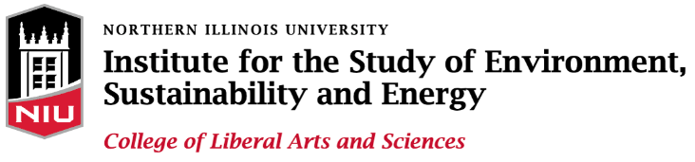

Table of Contents

Executive Summary 2
About the Authors 3
Methods 3
Survey Design 3
Recruitment 3
Respondent Demographics 4
Attitudes 6
Support for Sustainability 8
Campus Projects 8
Activities 9
Behaviors 11
Academics 13
Knowledge 14
Resident Halls 15
Sustainable Foods 18
Infrastructure 18
Waste Management 19
Transportation 20
Conclusion and Next Steps 22

Executive Summary

The Behaviors, Attitudes, Resources, and Knowledge of Sustainability survey (BARKS) is a student led research project assessing a variety of the opinions and understandings of sustainability among faculty, students, and staff at Northern Illinois University. The survey is supported by the Institute for the study of Energy Sustainability and Energy (ESE) and the Office of Student Engagement and Experiential Learning (OSEEL) Student Engagement Fund. BARKS aims to provide a broad understanding of the campus community’s preferences towards sustainability with the hope that the information gathered can better inform the university’s broader efforts at becoming more sustainable.
After a successful inaugural survey in 2018, the most recent iteration of BARKS was fielded between September 28th, 2023, and October 30th 2023, with 978 respondents from across campus. The survey contains a wide variety of questions on issues of sustainability, climate change, and environmentalism on campus and around the world. This report does not attempt to summarize all the potentially valuable information contained in the data. For those who are interested, an anonymized dataset is available for any campus stakeholder. Rather than a fully comprehensive account, this report focuses on a few key trends that are apparent in the gathering responses.
First, the report suggests strong support for sustainability and concern for environmental issues across campus. Students, faculty, and staff all expressed high levels of support for the importance of sustainability and are concerned about environmental issues like climate change. Many are already performing a wide variety of pro-environmental behaviors to reduce their own impact.
Second, there is broad support for the variety of ongoing sustainability initiatives on campus. However, there was also room for improvement. Only half of respondents believe NIU is a leader in sustainability. There is broad interest in sustainability opportunities in the classroom and through on-campus activities. For example, one third of respondents reported not engaging with sustainability themes in any of their classes. Meanwhile, a common theme in open-ended responses was the preference for more on campus sustainability programming.
Finally, the report examines attitudes toward many of the primary areas of environmental impact that occur on campus. Residence halls, campus dining, energy, and transportation play outsize roles in the university’s effect on environmental sustainability. In general, there appears to be broad support for existing sustainability efforts. Yet there is plenty of room for improvement to help members of the campus community make sustainable decisions, such as making recycling available on campus, and make the university more sustainable.

About the Authors
Oliver Myers is a senior Environmental Studies major earning their certificate in Social Entrepreneurship. They were the primary author of the report and the chief communications officer.
Jonathan Durbin is a junior Math major within the Mathematical Science Department. He compiled data from survey results and created graphs within the report.
Eman Mohammad is a second-year Doctoral student within the Political Science Department. She focused on methodology and survey design.
Dr. Colin Kuehl is an Assistant Professor in the Department of Political Science and Institute for the Study of the Environment Sustainability and Energy. He was Yoda for the BARKS team padawans.

Methods

Survey Design
Northern Illinois University’s BARKS (Behavior, Attitude, Resources, and Knowledge of Sustainability) survey was created to gauge a variety of attitudes of faculty, staff, and students within the NIU community held toward sustainability.
The survey consists of three primary components. Demographics, which include: gender, ethnicity, age, affiliation with the university, and income. Environmental attitudes, which include: environmental concern, environmental identification, and view of campus sustainability efforts. Environmental behaviors, which includes: participation in on-campus clubs, organizations, and courses. Where possible, questions replicate those found in the academic literature and similar campus surveys of sustainability fielded across the country and world (Slagel 2022). The 2023 largely replicates many of the same questions 2018 version with additional questions on commuting patterns and an embedded survey experiment.

Recruitment
The survey was fielded completely online using Qualtrics survey software. The survey aimed to understand sustainability attitudes of the campus, so invitations were sent to all NIU students, faculty, and staff. To induce participation, respondents could enter a raffle for one of 15 $20 gift cards to Huskie Books and Gear. Overall, 976 quality responses were recorded for an overall response rate of 5.25% (Student – 3.6%; Staff – 10.7; Faculty – 15.8%). Though seemingly low, this rate was in line with expectations and industry standards.
Invitations to complete this survey were initially sent to the NIU community on September 28th, 2023, with several follow-up and reminder emails sent throughout the month of October. Flyers and QR codes linked directly to the survey were used to recruit respondents. In addition, tabling efforts in Barsema Hall were made by students to gain further attention of the College of Business faculty, staff, and students. The highest response rate came from NIU Today/other university emails sent from end of September through October. Emails were sent to all students a total of five times -- twice through BARKS dedicated emails and three times through The Weekly Scroll. Emails were also sent to students, staff, and faculty through NIU Today on four occasions. The survey was closed on October 20th.

Data Cleaning
The survey received 1572 responses in total, some of which shared identical open-ended responses. Looking at these responses it was discovered that they were submitted in batches. These batches selected alphabetically convenient responses for drop-down questions (ex. for Major: Art, Art History, Anthropology, etc...). The research team thinks these were likely due to bots or other bad faith actors taking the survey. Using k-means clustering similar open-ended responses were grouped then the dataset was manually reviewed, 183 responses were deemed suspicious and removed. An additional 413 responses were removed either for opting out, ineligibility, or incompletion.

Respondent Demographics
To begin, it is important to understand the demographics of the survey participants and how they compare to the population of the university as a whole. While the survey is aimed at a comprehensive understanding of campus attitudes, it is important to note that the sample of respondents is not representative of the campus as a whole.
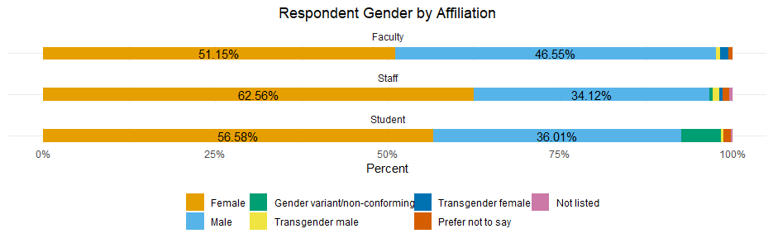
Figure 1 Question: What is your gender? – Faculty vs Staff vs Student
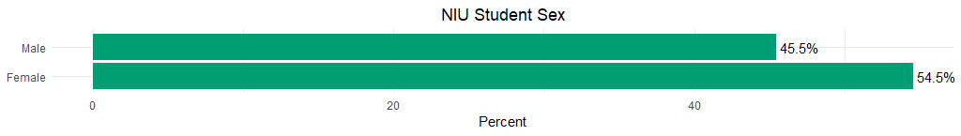
Figure 2 (Data from Academic Affairs)

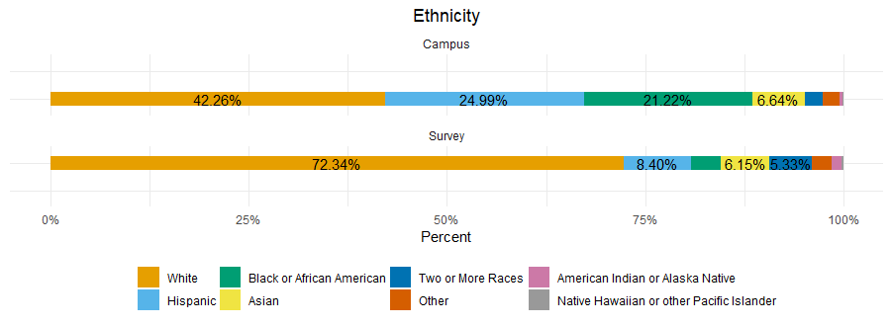
Figure 3 Question: I identify my ethnicity as (select all that apply)
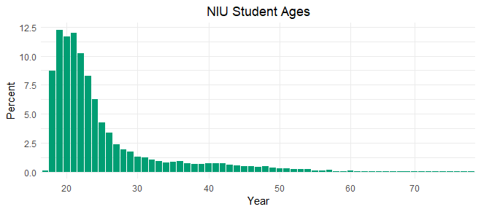
Figure 4 (Data from Academic Affairs)
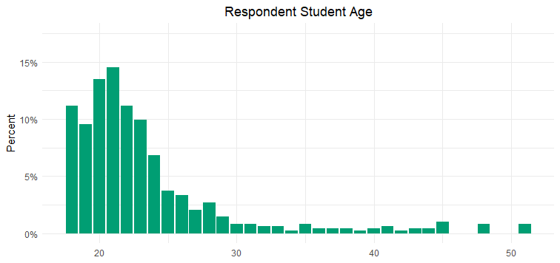
Figure 5 Question: What is your age? (open ended)

It is seen from the Survey’s demographic questions that the survey did not fully capture a representative sample of the NIU Campus. In particular, the white population and females are overrepresented in the sample (when comparing Campus Sex to Survey Gender). The survey achieves representative with student ages with a minor emphasis on 21- and 22-year-olds. The BARKS survey found that the median student age is 21, the median staff age is 38, and the median faculty age is 36. The distribution of age of students who took the BARKS survey has very similar measures of central tendency and skewness.
Of students who selected a major, 5.90% stated they were Environmental Studies majors. With the over representation of Environmental Studies majors and white women, this sample will bias environmental concern.
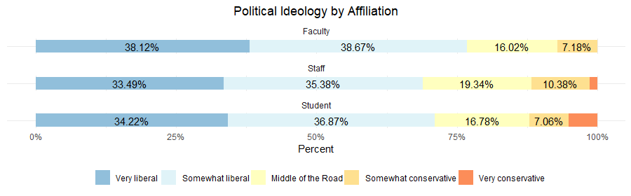
Figure 6 Question: Generally speaking, do you consider yourself to be politically:

Attitudes
The following pages discuss the attitudes of respondents towards NIU’s various sustainability initiatives as well as their personal sustainability attitudes. Furthermore, these questions introduced and asked the NIU community for their opinion on the future of on-campus sustainability projects. The Climate Action Plan outlined these projects in a draft sent to the campus community at the beginning of Fall 2023. These then lead to attitudes towards participating in activities on campus.
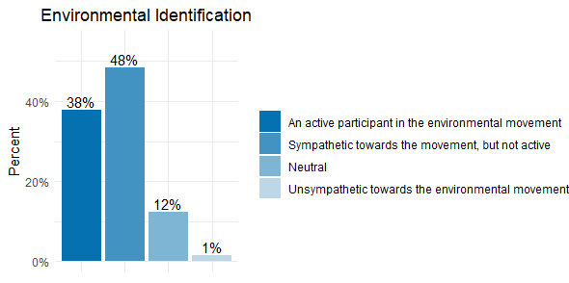
Figure 7 Questions: Thinking specifically about the environmental movement, do you think of yourself as?

Figure 7 shows a broad measure of concern for the environment. Identifying as a member of the environmental movement has been shown elsewhere (Sparks 2021) to highly correlate with other, more in-depth, measures of environmental attitudes and behavior. 3/4th of respondents suggested that they were active or sympathetic toward environmental support. This is further supported by high levels of concern for the environment shown by faculty, students, and staff. Across all respondents 80% were concerned and very concerned about environmental issues.
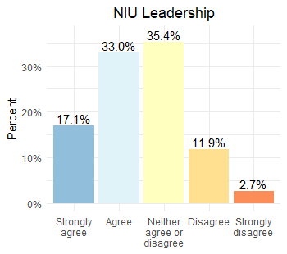  Figure 8 Question: I believe NIU is a leader in sustainable practices among other universities | 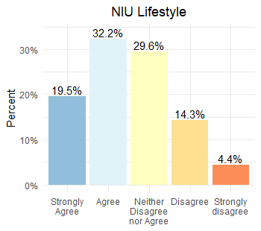  Figure 9 Question: Indicate the degree to which you agree or disagree with the following statement – My lifestyle has become more sustainable since coming to NIU

Support for Sustainability
The questions above indicate that people in the NIU community care about campus sustainability and an environmentally friendly lifestyle. The university’s efforts to improve sustainability were also noted. Around half of respondents think NIU is a leader in sustainable practices and a similar proportion believe their lifestyle has become more sustainable since coming to campus. While half would be a substantial portion, it can be assumed that individuals concerned with environmental problems are overrepresented in this sample. Additionally, students were the most likely to be critical of NIU leadership with over 15% selecting either “Disagree” or “Strongly disagree” compared to 10% for faculty and 13% for staff. The largest difference was in those who selected “Neither agree or disagree” with students at 39.61%, faculty at 27.72%, and staff at 31.20%. This suggests that if NIU improved upon its sharing of environmental actions leadership would gain considerably more support from the student body.

There are a number of ongoing sustainability initiatives on campus and other ideas suggested throughout the campus sustainability plan. The figure below shows the variety of support for these projects.

Campus Projects

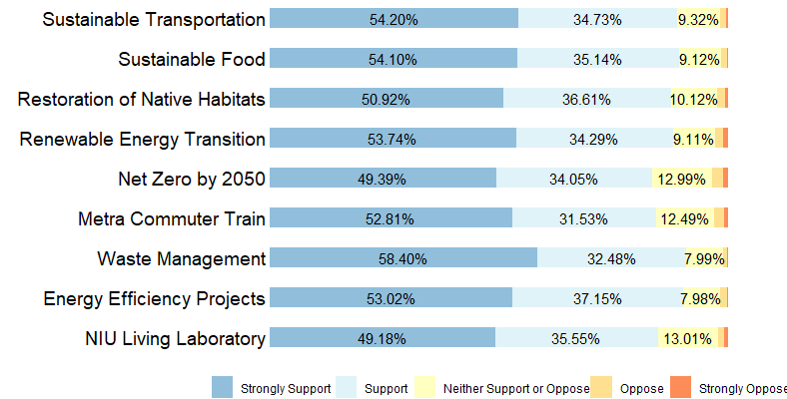
Figure 10 Question: Work is currently being done across campus and in the community on a number of sustainability initiatives. In general, how much do you support each of these proposed or on-going sustainability projects?
Campus projects, as outlined in the Sustainability and Climate Action Plan draft, included:
- Campus Project 1: Sustainable Transportation
  - Making campus transportation more sustainable (e.g. EV charging stations, better bus routes, bike share and car share programs, etc.) (Figure 34)
- Campus Project 2: Sustainable Food
  - Promoting sustainable food (e.g. adding food gardens/CSA’s on campus)
- Campus Project 3: Restoration of Native Habitats
- Campus Project 4: Renewable Energy Transition
  - Transitioning to renewable energy (e.g. solar panels on buildings, purchasing other forms of renewable energy) (Figure 29)
- Campus Project 5: Net Zero by 2050
  - Campus commitment to net-zero greenhouse gas emissions by 2050 or earlier
- Campus Project 6: Metra Commuter Train
  - Extending the Metra commuter train to DeKalb (Figure 35)
- Campus Project 7: Waste Management
  - Waste management activities (e.g. improved recycling programs, composting of food waste from campus dining halls) (Figure 31)
- Campus Project 8: Energy Efficiency Projects
  - Energy efficiency projects (e.g. switching to LED lighting in buildings) (Figure 30)
- Campus Project 9: NIU Living Labratory
  - Using the campus as a living laboratory (e.g. linking campus sustainability projects to student classroom, research, or other engagement activities) (Figure 18)
The most supported campus project with 58.40% of respondents strongly in supporting, is waste management activities, which include initiatives such as improved recycling programs and composting food waste from the dining halls. This support was common in the open-ended portion of the survey.
- “I want NIU to find a way to reduce food waste from the on-campus dining halls. There is a lot of food waste here that impacts the university’s carbon footprint.”
Through the open-ended questions asked in the survey, one respondent stated the following regarding NIU’s sustainability initiatives and the impact awareness can have on getting people within the community involved.
- “I wasn’t aware of NIU efforts. So possibly, strategize increasing awareness of these efforts may help others get involved.”
People in the NIU community identified activities already participating in outlined in these sustainability projects within the open-ended sections of the survey. One includes topics such as sustainable foods and using NIU as a living laboratory, detailed below.
- “Was the intern for the NIU gardens for a year, earned a certificate in sustainable food systems, volunteered at gardens, incorporated into nutrition curriculum”

Activities
There are also ongoing sustainability-related activities on campus. For the following data, the percentages of “very willing” and “willing” were totaled individually for faculty, staff, and students in order to gauge overall willingness to participate in sustainable on-campus activities. There was high support from all three groups with faculty at 85.94%, staff at 79.15%, and students at 73.84%. This could be brought into future on-campus sustainability initiatives by raising awareness and having further outreach with the NIU community. This could get more people involved not only in these sustainability activities, but also in creating an environmentally conscious community.
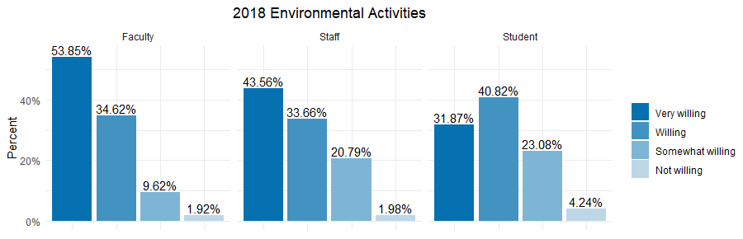
Figure 11 Question: How willing are you to participate in sustainability activities on campus? -- 2018
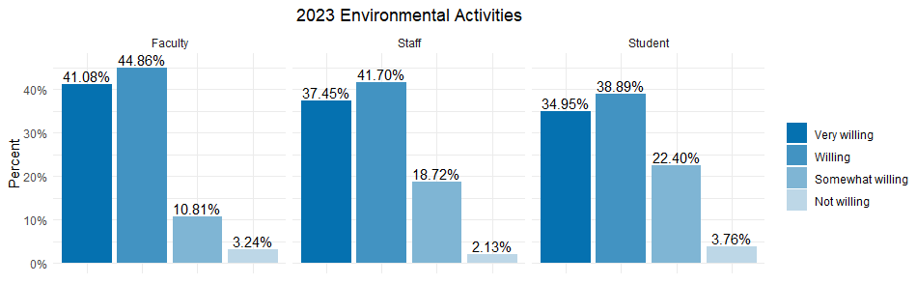
Figure 12 Question: How willing are you to participate in sustainability activities on campus? -- 2023
It can be observed that students continue to have a steady “willingness” (considering both “very willing” and “willing” as the general “willingness” between each of the groups of respondents) to participate in environmental activities. Through the open-ended questions asked in the survey, respondents stated the following regarding what they would like to see in environmental activities at NIU.
- “It would be cool if there was a weekly events calendar specifically for environmental stuff on campus that could be sent out.”
- “More gardens, and programs so everyone can get involved.”
- “I haven’t joined any clubs but I would love to!”
- “Better publicity of environmental protection.”
Furthermore, there were respondents who were eager to discuss their sustainability efforts.
- “I’ve planted 16 trees on campus and maintained flower beds with indigenous prairie plants.”
- “STEM cafes.”

Behaviors
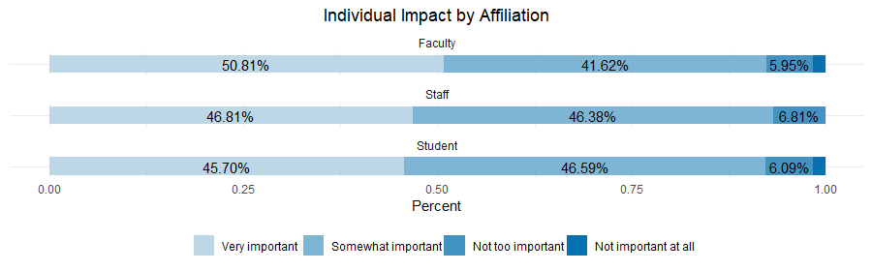
Figure 13 Question: How important do you think it is for you to address your own personal impact on the environment?
Across campus, people agree it is important to address their individual impact on the environment. Interestingly, more students think that it is “not too import” or “not important at all” than faculty and staff.
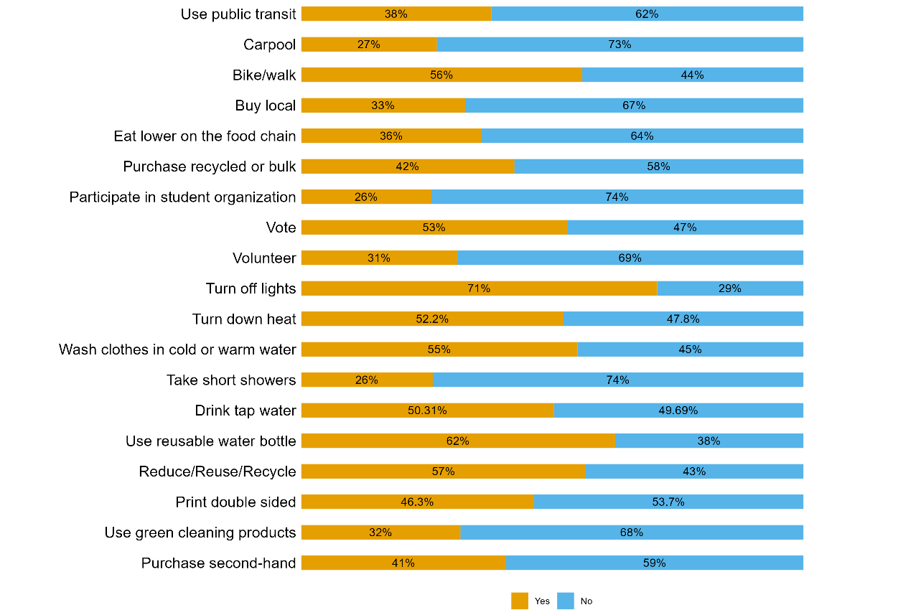
Figure 14 Questions: Which of the following choices or activities describe your current lifestyle? (Check all that apply)
Figure 14 shows the wide variety of behaviors that the NIU community is already doing to promote sustainability. From the data collected, Figure 14 demonstrates that only a little over half of the respondents (53%) claim that they vote. Some of the top personal behaviors done by our respondents include turning off the lights (71%), use reusable water bottle (62%), and reduce/reuse/recycle (57%). It is also seen that 30-50% are participating in activities that take a little more effort and include more thought into any behavioral/lifestyle changes. These include taking short showers (26%), printing double sided (46.3%), and turning the heat down (52.2%). As for high effort activities that would require a larger change in lifestyle and behavior, it is observed that 20-30% of respondents participate in them, such as participating in student organizations (26%) and volunteering (31%).
A significant portion of respondents (30-40%) are not participating in low effort activities that are not major lifestyle changes/behaviors. Meanwhile, high effort activities have a large amount of support for high them being effort activities with ¼ of respondents saying that they participate in student organizations and 1/3 of respondents saying they participate in volunteering.
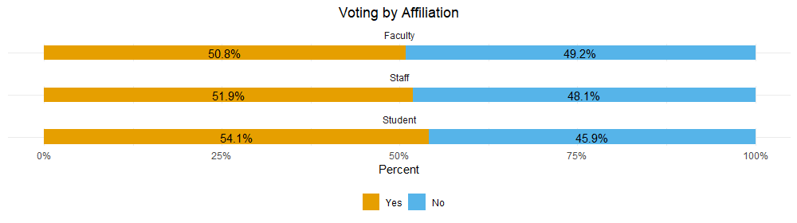
Figure 15 Voting – Faculty vs Staff vs Student
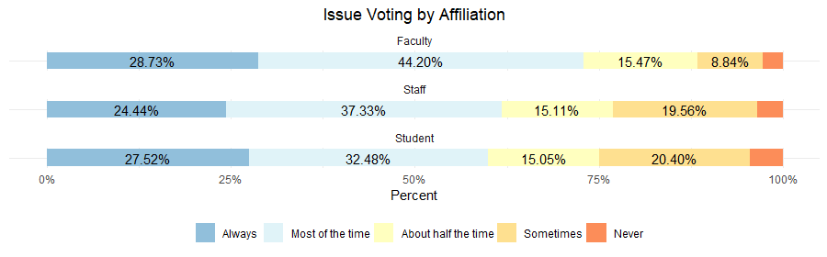
Figure 16 Question: Do you consider environmental concerns when deciding how to vote? -- Faculty vs Staff vs Student
Participation in politics is also a crucial component of the push for sustainabillity. Students are the least likely to consider environmental concerns when voting with 1 in 4 students saying they are unlikely to consider environmental issues. As shown by Figure 16, the student respondents do not consider environmental concerns when voting (total 24.95% combining “sometimes” and “never” percentages) versus faculty (total 11.60%). When breaking down the “voting” lifestyle by affiliation, students had the highest percentage of engaging in voting as a choice that describes their current lifestyle.

Academics

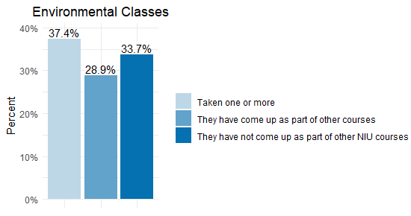
Figure 17 Question: During your time at NIU how often have you taken courses that address sustainability issues?
Of the NIU student responses, only one-third of students have not taken courses that address sustainability issues/come across sustainability issues as a part of other NIU courses. It is important to keep in mind that this is amongst students who volunteered to complete a survey on sustainability, so the percentage among the student body is likely much lower.
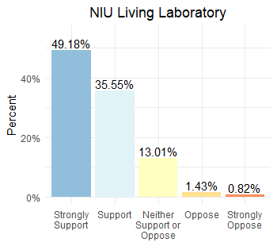
Figure 18 Campus project 9 -- Using campus as a living laboratory (e.g. linking campus sustainability projects to student classroom, research or other engagement activities).
A majority of respondents (84.73%) support using the campus as a living laboratory to link more students with other campus sustainability projects as well as introducing various research and engagement opportunities for students.
Through the open-ended questions asked in the survey, respondents stated the following regarding the importance of environmental education.
- “Making environmental education a necessity in every learning process will go a long way toward changing people’s mindsets and attitudes about the planet and the environment.”
- “We must strengthen publicity and education, and strive to enhance the awareness of population, resources and environmental protection of the whole nation.”
- “I wish more of my classes mentioned sustainability. I think if it was a huge campus-wide initiative, more people would be talking about it, rather than just the people taking specific courses. The only classes I had where it was mentioned were gen ed geology classes.”

Knowledge
The following graphs show the number of questions answered correctly, regarding sustainability literacy in both the 2023 and 2018 surveys.
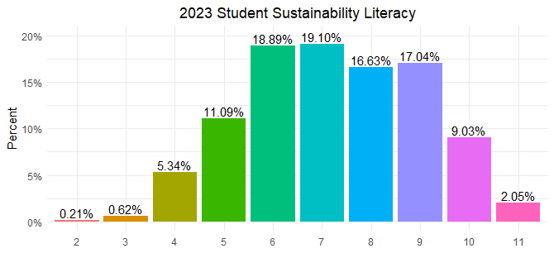
Figure 19 Knowledge Score – 2023 Student Specific
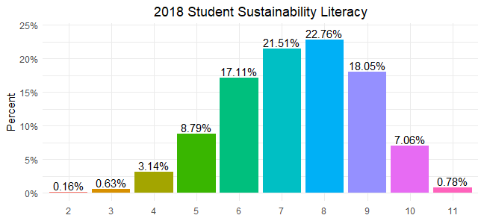
Figure 20 Knowledge Score – 2018 Student Specific
In both the 2018 and 2023 surveys, questions used to gauge respondent knowledge on environmental issues were asked. Taking the 11 that crossed over between the two forms of the survey, there is a decrease in the mean from 7.51 in 2018 to 7.06 in 2023. This change in mean score shows a decrease in the campus respondents' general knowledge of environmental issues (Kuehl 2023).
Between 2018 and 2023, there was a decrease in the mean of knowledge scores between faculty, staff, and students. From 2018 to 2023, the faculty mean score went from 8.58 to 6.72; the staff mean score went from 7.89 to 6.88; and the student mean score went from 7.36 to 7.25.

Resident Halls
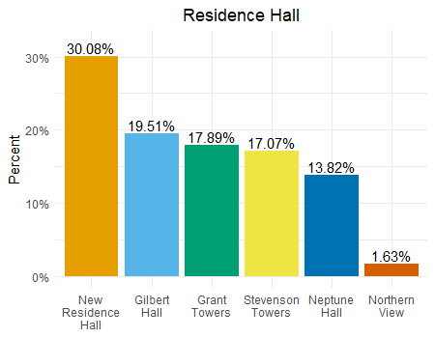  Figure 21 Question: Which resident hall do you live in? | 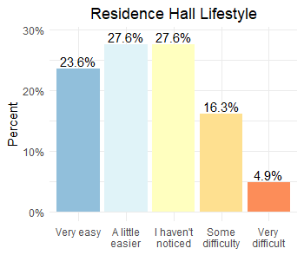  Figure 22 Question: My residence halls have made it easy for me to live green (e.g. recycling is accessible, composting available, saving power, etc.).
Students living on campus have the greatest interaction with university facilities and sustainability policies making them a particularly crucial component of the campus population. A total of 124 respondents were students living in residence halls. About half of the students who responded to this question (Figure 22) stated they either haven’t noticed a difference (27.6%) or have had some level of difficulty (21.2%) living green within their residence halls.
Meaning, roughly half of students who responded to the question stated that they have found some level of ease in increasing green living in their residence halls, yet the change in sustainable living since coming to NIU (specifically looking at residence halls students – Figure 21) is nearly identical to the overall NIU lifestyle graph (Figure 9)
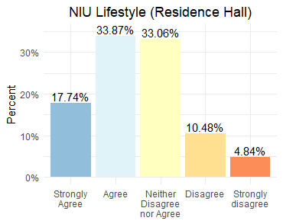  Figure 23 Question: Indicate the degree to which you agree or disagree with the following statement – My lifestyle has become more sustainable since coming to NIU. (Residence hall specific) | 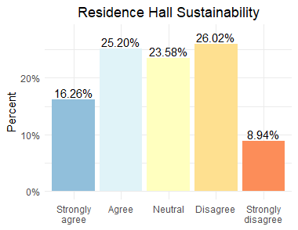  Figure 24 Question: My residents hall has promoted building habits for sustainability (e.g. quick showers, “going green”, events, general tips, information for going green, etc.).
About 26% of students living in residence halls disagree to a degree with the statement “my residence hall has promoted building habits for sustainability” with nearly 9% strongly disagreeing with the statement. This suggests that students living in residence halls, on some level, are struggling with sustainability while living on campus.
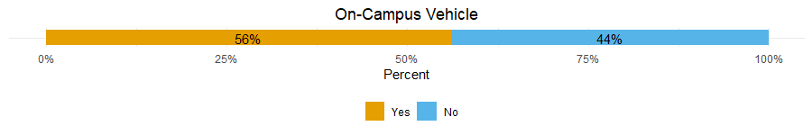
Figure 25 Question: Do you have a motor vehicle on campus? -- Residence hall students specifically.

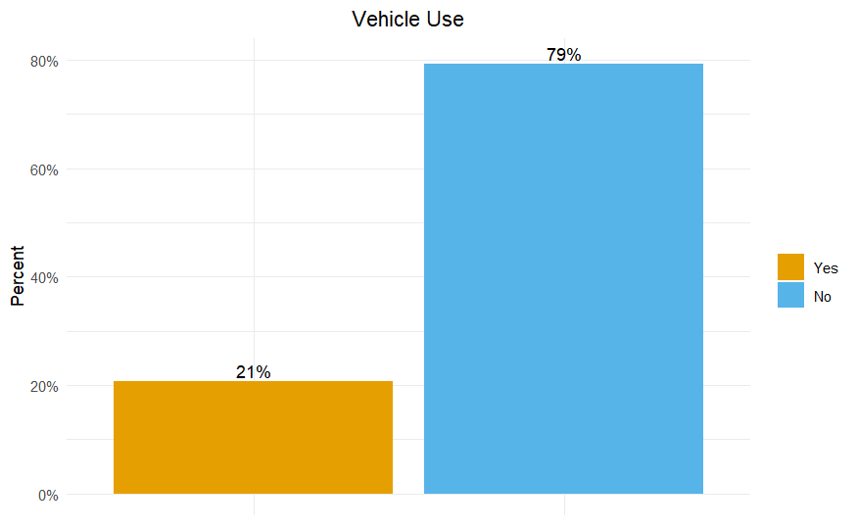
Figure 26 Question: Do you drive a motor vehicle to get to campus? – Residence hall students specifically.
A majority of students living in residence halls do own a car. Surprisingly, 21% of students who live in residence halls drive a motor vehicle to get to their classes. From that, it can be assumed that more students who live in residence halls likely own cars, but don’t use them to get to get to their classes

Sustainable Foods
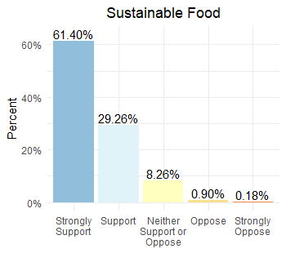  Figure 27 Campus project 2 – Promoting sustainable food (e.g. adding food gardens/CSAs on campus) -- Residence Hall students specifically | 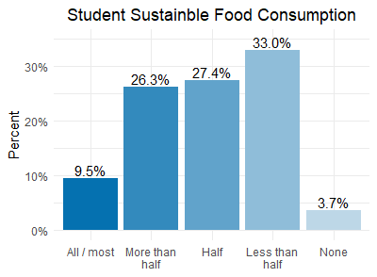  Figure 28 Question: During the past year, about how much of the food you consumed would be considered “sustainable food”? -- Residence Hall students specifically
Promoting sustainable foods, as a campus sustainability initiative, was strongly supported by students who are living in residence halls. Meanwhile, the actual consumption rate of sustainable food by students who live in residence halls is rather low.

Infrastructure

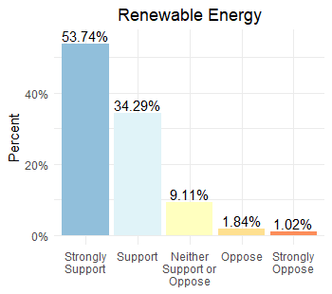  Figure 29 Campus project 4 - Transitioning to renewable energy (e.g. solar panels on buildings, purchasing other forms of renewable energy). | 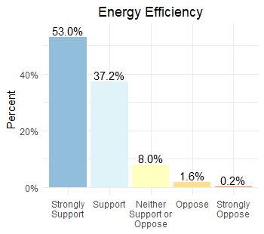  Figure 30 Campus project 8 - Energy efficiency projects (e.g. switching to LED lighting in buildings).

Again, responses to open-ended questions suggest a strong interest in using solar as a campus energy source and support for electrification more broadly.
- “More solar would be great.”
- “More solar use, more prairie grass but not weed patches.”
- “Update/modernize buildings.”
- “LED buildings as we continue to build and renovate.”
- “Promoting electric mobility promotes renewable energy”.

Waste Management
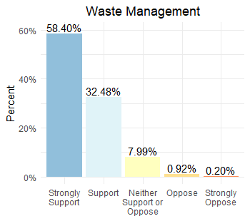
Figure 31 Campus project 7 - Waste management activities (e.g. improved recycling programs, composting food waste from dining halls).
Improving waste management, out of all the campus projects, had the highest support from respondents.
Through the open-ended questions asked in the survey, respondents stated the following regarding waste management.
- “NIU should be more sustainable in keeping their surroundings clean.”
- “Ban plastic bags even those that are reusable.”
- “Also, recycling needs to happen, I found out that in residence halls NIU throws trash and recycling together.”
- “Improve trash pickup/anti-littering.”
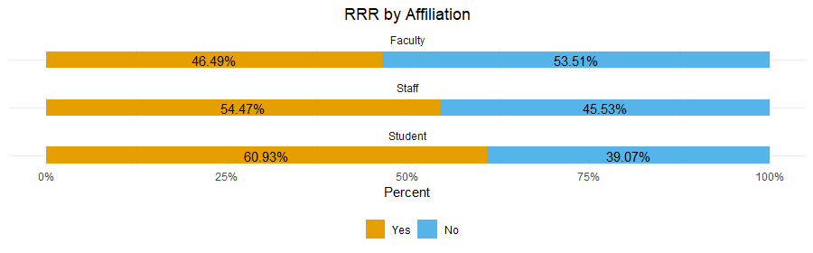
Figure 32 Reduce/Reuse/Recycling by affiliation taken from lifestyle check all that apply.
While improvement of waste management was the most supported sustainability initiative, only 46.49% of faculty said that they participate in reduce/reuse/recycle.

Transportation

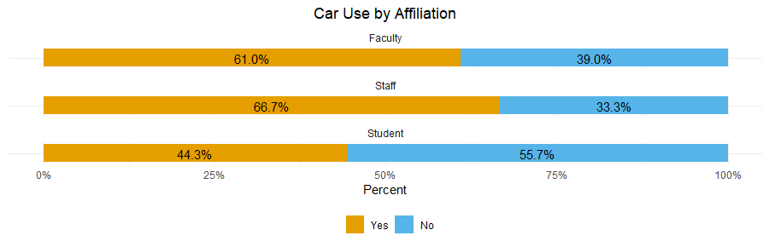
Figure 33 Question: Do you drive a motor vehicle to campus? – Faculty vs Staff vs Student
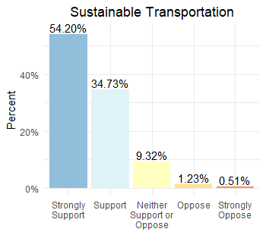  Figure 34 Campus project 1 - Make campus transportation more sustainable (e.g. EV charging stations, better bus routes, bike share and car share programs, etc.) | 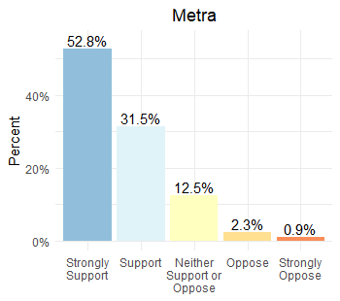  Figure 35 Campus project 6 - Extending the Metra commuter train to DeKalb.
One of NIU’s largest climate impacts comes from transportation to and from campus.
NIU sustainability projects regarding transportation were also found to have a lot of support from respondents in the survey.
From two questions on the survey: “What type of vehicle do you normally drive to campus?” and “How is the vehicle you normally drive powered?” it is shown that the most popular vehicle body type is Sedan, by far the most popular vehicle type being gas powered Sedans:
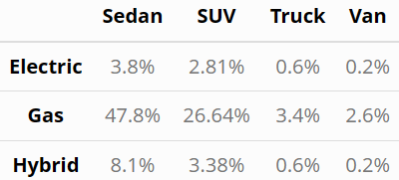
Table 1
Through the open-ended questions asked in the survey, respondents stated the following transportation on, around, and to campus.
- “The closing of Normal Rd. was a great advancement toward creating better and safer walkable parts of campus.”
- “I think more transportation like bus routes etc.”
- “I would like to see to see the Metra extended to DeKalb.”
- “Cutting down on the massive parking lots, drastically raising the price of parking, removing roads like the Normal Rd project, etc.”

Conclusion and Next Steps
There are plans to replicate BARKS in 2027. It will continue to be a survey but will include new questions and sections from the input received over time and changes made.
Contact us: The BARKS dataset and codebook are available upon request. If you would like the original data or have any other questions about the survey, please contact Dr. Colin Kueh(ckuehl@niu.edu).
Citations:
Slagle, K. M., and Sintov. N. 2022. 2021 Campus Sustainability Survey: Results and Trends. A Report by the Environmental and Social Sustainability Lab. The Ohio State University, School of Environment and Natural Resources.
Sparks, A. C., Henderson, G. L., Sriram, S. K., & Smith, E. R. A. N. (2020). Society &amp; Natural Resources, 34(3), 291–310. doi:10.1080/08941920.2020.1817644

