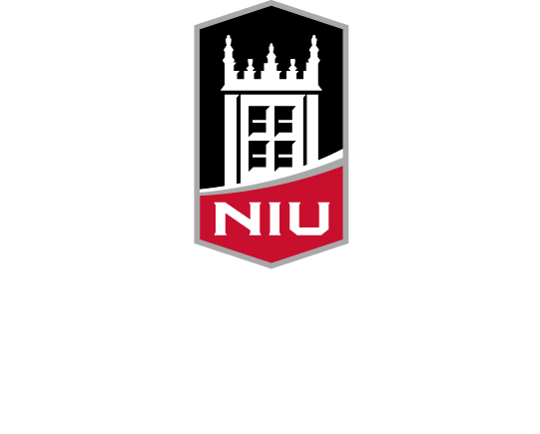
NIU Office of the
Ombudsperson
Annual Report
for Academic Year 2022-23
Submitted by Sandy Cox, Ombudsperson
niu.edu/ombuds
Contents
About Our Office 4
Mission and Vision 5
Mission 5
Vision 5
Value of an Ombuds Office 6
A Visit to Our Office 7
Data 8
Changes to Data Collection 8
Visitors by Classification 8
Visitor Concerns 9
Top Five Reasons for Visits per Category 9
Additional Work of Our Office 11
Services by Type 11
Facilitated Discussions/Mediations by Semester 11
Goals 12
Reflections 13
Acknowledgements 14

Our Office of the Ombudsperson is a confidential, informal, neutral and independent resource for assisting in navigating concerns that impact success and well-being at NIU. Our office serves our entire campus community including faculty, staff, students and administrators.
As a confidential resource, members of our office do not disclose who visits our office or the content of the conversations, and we do not keep records on visitors, visits and interactions. The only exceptions to confidentiality are concerns for risk of harm to self or others and mandated reporting specific to child/elder abuse.
Pursuant to Article 20 of the bylaws of NIU, the university ombudsperson is a direct report to the president and is evaluated by the University Council.
The NIU Office of the Ombudsperson adheres to the standards of practice and code of ethics outlines by the International Ombuds Association.

About Our Office
Our office is staffed by Ombudsperson Sandy Cox and Administrative Assistant Patricia Gingrich. Gingrich retired from NIU at the close of the fiscal year. Gingrich had a long, respected history working at NIU. She had a wealth of NIU knowledge and unmatched kindness working with others.
Ombudsperson Cox reports to NIU President Lisa C. Freeman and is structured under the President’s Office as part of University Services.
Our role is providing direct services to visitors; facilitated conversations and mediation; training and outreach; review and consultation on policies and procedures; sharing of nonidentifiable visitor themes and patterns to administration; collaborative feedback conversations with leadership; and participation in committees and meetings as appropriate.

Mission and Vision

Mission
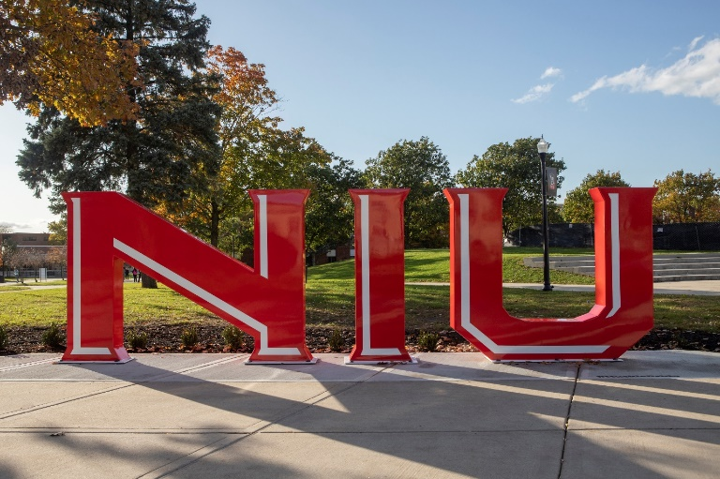
Our mission is to provide a safe, inclusive service to all NIU students and employees. We listen, help navigate paths to resolution of concerns, identify relevant policies and practices, and bridge resources for support. We assist the university in identifying trends of concerns, and inform administrators and governing bodies regarding those concerns. We conduct ongoing review of policies and procedures to recommend changes that can potentially improve our university community.

Vision
A common theme that arose in meetings with individuals and groups this past year was the idea that going to the ombudsperson was intended for individuals who are in escalating conflict and have attempted everything else. The vision we have for the future of our office is to modify that understanding. We are here for when things escalate. However, our hope is that individuals will engage with our office early in their concerns/issues to seek intervention that could impact escalation to conflict or greater distress. We are working to do this by our messaging of also being a preventive office for campus issues through all of our marketing efforts. This includes an updated webpage and a strategic marketing plan supporting this messaging.

Value of an Ombuds Office
Our ombuds office has great value to students, employees and the entire university. We provide value by:
- Being a neutral party in which individuals experience an impartial perspective that helps them navigate their situation or concern.
- Providing an informal space for visitors to express their concerns and explore the resources they have available to utilize, understanding they are in control of what they do or do not choose to do.
- Minimizing the need for formal processes when appropriate or assisting visitors to understand and work through formal processes.
- Positively impacting the retention of students by helping navigate concerns that impact success and well-being.
- Identifying themes and patterns and offering ideas for supporting and addressing concerns that often positively impact workplace and student environments.
- Supporting staff and faculty to navigate their concerns in a more timely and concise way to minimize impact on work.
- Offering opportunities for individuals or groups to learn skills to manage challenging situations and conflicts and develop positive communication skills which impact healthier environments.
- Offering facilitated conversations and/or mediations that often keep issues from escalating.
- Providing a nonjudgmental space for individuals to feel empowered to voice their concerns, feel heard and understood, and develop a plan to help navigate issues in the future.
- Providing “shuttle diplomacy,” which means sharing information with relevant others to assist the visitor with addressing their concerns and desired outcomes when they feel unable to do so.

A Visit to Our Office
Visitors to our office engage in services through phone calls, emails and in-person contact. Email to ombuds@niu.edu is the primary way in which visitors reach out to our office. Visitors are offered various modalities of services that include in person, Teams, phone or email correspondence. The majority of visitors request Teams meetings.
In the first meeting with our ombudsperson, the guiding principles of our office are covered. Those principles include independence, impartiality/neutrality, informality and confidentiality. We discuss that though our ombuds office professionals are employed by NIU, our office is structured to be independent so that it can function from a neutral and impartial perspective. We explain that our ombudsperson’s role is not to advocate for individuals or the university, but to advocate for best practices, policies, procedures and positive experiences for all employees and students. We also explain that we are informal and do not serve notice to the university, investigate on the behalf of individuals or the university, or engage in a formal process or legal advice and guidance. We seek to keep up to date with policies and procedures and formal processes to best assist our visitors. Lastly, we remind visitors that we are confidential with the exception of individuals having thoughts of harm to self or others. It is also explained that we gather nonidentifiable information for the annual report and Title IX Clery reporting.
Visitors to our office often seek someone who will listen without judgment to their concerns and experiences. We discuss hopeful outcomes and explore various ways to navigate their situation to attempt to achieve a positive outcome. This often includes developing skills, practicing difficult conversations, assistance with developing written correspondence, and connecting to potential resources for assistance. At times, visitors or supportive resources request facilitated discussions and/or mediation services. In these situations, all parties involved must agree to a facilitated conversation or mediation. The ombudsperson requests to speak with all involved individually prior to a group meeting.

Data

Changes to Data Collection
We changed our system of data collection to OnBase to better support accurate, layered collection of data. Our office does not formally collect demographic information on visitors. As such, there is not accurate data on demographics of visitors beyond classification of type of employee or student. In future data collections, there will be the addition of risk, types of services utilized, how they were referred to the office, and resources utilized. We will also be looking to separate the data more specifically, students versus employees. Review and modification of the data collection process will be ongoing.

Visitors by Classification
Our office provided services to 796 individuals for the 2022-2023 academic year. The ranking of the classification of visitors to our office is as follows:

The percentage breakdown of classifications is included in this graph.
Employees consisted of 54% of the visitors this year, students 32% and other 14%.

Visitor Concerns
The collection of data typically gathered by ombuds offices are organized into seven categories. They include employment, student academic status, faculty and staff performance, student conduct, financial, classroom and miscellaneous. Below are the categories, ranked from highest to lowest, for visitor concerns.

FALL 2022
- Employment
- Faculty and Staff Perfomance
- Classroom
- Miscellaneous
- Student Academic Status
- Financial
- Student Conduct
SPRING 2023
- Employment
- Classroom
- Faculty and Staff Performance
- Miscellaneous
- Student Academic Status
- Student Conduct
- Financial

Top Five Reasons for Visits per Category
The following further clarifies the top five reasons visitors engaged with NIU ombuds services this past year by category.
CATEGORIES | REASONS
Employment | Morale  Supervisor Skills/Relationship with Employees  Personality Conflicts  Inadequate Staffing  Working Conditions
Classroom Instruction | Grade Appeal  Quality of Instruction  Course Syllabus  Personality Conflicts  Policy
Faculty and Staff Performance | Unprofessionalism  Intimidation  Derogatory Comments  Retaliation  Discrimination
Student Conduct | Academic Misconduct  Discrimination  Policy  Classroom Disruption  Records
Student Academic Status | Academic Advising  Thesis/Dissertation  Class Scheduling  Withdrawals  Probation/Dismissal
Financial | Payroll  Emergency Funding  Tuition  Housing  Financial Aid
Miscellaneous | Interpersonal Concerns  Disability Accommodations  Safety Issues  Ethical Considerations  Policy Issues/Development

Additional Work of Our Office
Meeting with visitors is the primary service of our office. However, we engage in a wide range of other services. The charts below identify the diverse services we have provided this past year. We also actively participate in shared governance committees, presidential commissions and advisory committees.

Services by Type

Facilitated Discussions/Mediations by Semester

Goals
- Implementation of a new strategic marketing plan.
- Seek more opportunities for provision of outreach and training.
- Modify our administrative assistant position into a program coordinator position with the vision of this position providing more direct services through the office.
- Restart our graduate assistantship program.
- Continue to develop a greater understanding of NIU policies, procedures and culture.
- Continue to develop and nurture collaborative relationships across campus to best serve students and employees.
- Expand collaborations with campus resources to support student and employee positive experiences at NIU.
- Continue to engage in professional development to ensure best practices through our office.
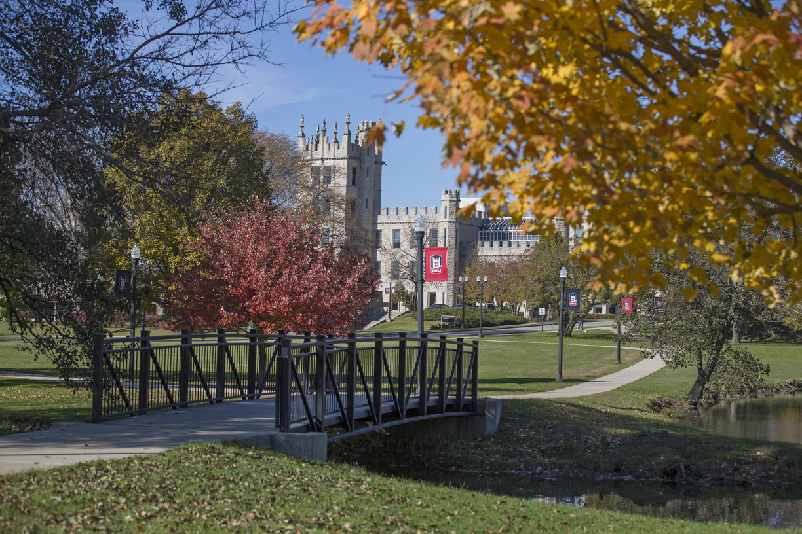

Reflections
Visitors consistently expressed gratitude with their experiences of feeling heard and not judged. Many shared that feeling heard was not a common experience for them and sometimes was the outcome they needed. Offerings of training in expanding listening skills may be helpful.
Historical annual reports indicate a level of incivility across campus. This past year indicated a sense of individuals feeling overwhelmed, experiencing well-being challenges, and less compassion and kindness being present in their experiences. The university has engaged in policies and supportive services/outreach to support assisting these experiences. Continued support of encouraging individual and group well-being initiatives as part of our campus culture could be beneficial.
Our office tends to see many people who have various challenges going on and/or distressful events that impact their work or student success. There is a common theme of a need for procedural fairness, which is a positive approach. However, the idea/practice of fairness is often misunderstood and can impact our ability to respond in a compassionate manner. It could be beneficial to explore the development of “compassionate policies” and/or empower faculty/staff to explore outcomes outside of traditional policies to develop a compassionate response when appropriate.
Morale concerns was a theme that was very prevalent this past year. It is well-researched that COVID-19 has had a lingering impact on individuals’ overall wellness and fatigue of all kinds. University environments are an exciting place to be with the energy of learning and growth. They are also very demanding environments on all. Exploring opportunities to increase morale within the various environments could be very worthwhile to the overall functioning of our university.

Acknowledgements
I thank everyone I have met this past year. It has been an experience of individuals being open, kind and gracious. I specifically express my deep gratitude for Patricia Gingrich, President Freeman and Liz Wright. Their support and guidance have been invaluable in my transition to NIU. I am deeply grateful to be part of our Huskie community.
