Occupational Health and Safety Program for Animal Workers

In accordance with the Public Health Service Policy on Humane Care and Use of Laboratory Animals, which requires awardee institutions to establish an Occupational Health and Safety Program for all personnel who work in laboratory animal facilities or have contact with animals, NIU has established the following policy with which all personnel who work around live vertebrate animals should be familiar.

This Occupational Health and Safety Program for Animal Workers is administered by the Office of Research Compliance, Integrity, and Safety (ORCIS) under the guidance of the Institutional Animal Care and Use Committee (IACUC).

- Who should participate?
The program covers all personnel involved in live vertebrate animal care and use at Northern Illinois University. Participation in this program is mandatory. This includes, but is not limited to NIU students and employees, full or part-time.

How to participate
Activities with live vertebrate animals have been divided into general categories of risk. However, a particular activity may change its risk category based on information provided. The Laboratory Safety Manager and Attending Veterinarian, in consultation with the IACUC, will make the final determination for each protocol’s hazard level. The chart below provides a general guide to activities likely to fall into each hazard level. See Appendix A: Process Flow Chart for more specific information on the process. Appendix B: Risk Assessment Form is an example of the information that is documented. The form information will be stored in the protocol record in InfoEd.

Hazard Level
Low | Course work with animals  Observational Field Work  Field research with fish, amphibians, nonvenomous reptiles, & birds
Moderate | Animal facility husbandry  Laboratory animal research activities  Field research with venomous species and mammals other than non-human primates
High | Laboratory animal research involving biological or chemical hazards  Field research involving non-human primates

At the low hazard level:
- ORCIS will provide the PI with protocol specific information on potential hazards and protective measures available to participants.
- The PI is required to:
  - Distribute the information regarding hazards and protective measures to participants prior to contact with the animals, through recorded lecture and/or written documents.
  - Review the provided hazard-specific information with all participants.
  - Document that the information has been provided to all participants (with provided sign-in form) and submit this documentation to the Laboratory Safety Manager, ORCIS.
At moderate hazard level, in addition to the actions listed above:
- Participants will complete a Health Questionnaire. See Appendix C for an example of the Health Questionnaire. If the participant chooses to go to Physicians Immediate Care, they must obtain a medical authorization from the Lab Safety Manager to cover the charges. Alternatively, the participant can go to their own preferred licensed health care provider. Costs will not be covered by NIU in this instance. The healthcare provider will perform a physical (if necessary) and review the information on the form with the participant. The healthcare provider will evaluate each participant and make a Health Assessment that will include one of the following:
  - The individual can work with no restrictions.
  - The individual can work with the specific restrictions: ____________.
  - The individual should not participate. Further follow-up requested.
At the high hazard level, in addition to the actions listed above:
- The healthcare provider will also receive the potential hazards and will have the opportunity to provide input.
Regardless of the risk level designated by the IACUC, any person involved with the care and use of animals through an NIU-associated teaching, research, or training activity may request consultation with Physicians Immediate Care or a preferred licensed health care provider at any time by contacting the Laboratory Safety Manager.

To ensure confidentiality and comply with all federal and state regulations, all medical information provided will be given directly to the health care provider without review by NIU.

- Vaccinations
The following vaccinations are strongly suggested for all participants. Tetanus, Diphtheria, Pertussis (Tdap) in the past 10 years, Hepatitis A, Hepatitis B and an annual flu shot.

- Testing
Participants in all protocols involving nonhuman primates (regardless of hazard level) will be required to have an annual tuberculosis (TB) skin test. A waiver is given only after consultation with the Occupational Health Specialist.

- Special precautions for pregnancy, illness, immune suppression
Any condition which may put the worker at additional risk such as pregnancy, illness or compromised immunity should be discussed with a healthcare provider. Information about the type of work performed and the animals in use should be shared with the healthcare provider. Any suggested accommodations should be forwarded to the supervisor/principal investigator for implementation, or alternatively, participants may complete a Health Questionnaire form and submit it to the healthcare provider.

- Hazard and Risk Identification and Assessment
Hazard and risk assessment will be conducted annually for the animal facility staff in Montgomery Hall and Psychology. Hazard and risk assessment for each protocol will be done in cooperation with the PI. All PIs are responsible for informing new personnel about the hazard/risk assessment level of a protocol to which they are assigned and providing them with the appropriate materials relevant to hazard/risk level. Please contact ORCIS for the most recent assessment information and Hazard Analysis Form.

- Access by Housekeeping, Maintenance, or Other Non-Animal Care and Use Personnel
In situations where housekeeping, maintenance, or other non-animal care and use personnel must access the animal rooms, they are briefed on appropriate precautions, provided any appropriate PPE, and permitted in the area for a limited amount of time. A member of the animal care staff will be available for escort if needed. If there is extensive or prolonged work to be done, the animals will be removed prior to the individuals being allowed into the room.

- Reporting and Treating Injuries
  - Accident/Incident Report
In the event of an illness or injury, supervisors and/or the principal investigator will complete the online NIU accident/incident report. It will be routed to Laboratory Safety (ORCIS). The report includes the name of the injured person, his/her contact information, status (student, faculty, staff, or visitor), a description of the accident/incident, the response and medical treatment, if any, and any follow up or corrective action. If the incident also involves a Workman’s Compensation issue, the Human Resource Services office should also be notified so the proper documentation is completed.

  - Obtaining Medical Treatment
In the event of bites, scratches, illness or injury, supervisors and/or the principal investigator should be notified. In the case of a minor injury, Physicians Immediate Care is available M-F 8am -8pm, Saturday and Sunday 7:30 am-4:30 pm. Northwestern Medicine Kishwaukee Hospital Emergency Room is available 24 hours daily. In the event of a serious injury, medical assistance should be sought immediately. In the case of a medical emergency, CALL 911. Depending on employment status, circumstances associated with the injury, and insurance coverage, employees may be responsible for costs of care. Patients should NOT be taken to University Health Services for medical emergencies.
References

Guide for the Care and Use of Laboratory Animals, Institute of Laboratory Animal Resources, commission of Life Sciences, National Research Council, National Academy Press, 2011.

Occupational Health and Safety in the care and Use of Research Animals, Committee on Occupational Safety and Health in Research Animal Facilities, National Research Council, National Academy Press, 1997.

Annual Review

The IACUC will review and revise this procedure on an annual basis to reflect operational and procedural changes internal to the University as well as changes to applicable rules, regulations, and consensus standards.

Date | Reviewed by | Changes
2015 | IACUC | Initial
2016 | IACUC | Minor updates
2019 | IACUC | Minor updates
2020 | IACUC | Minor updates
2023 | IACUC | Minor updates

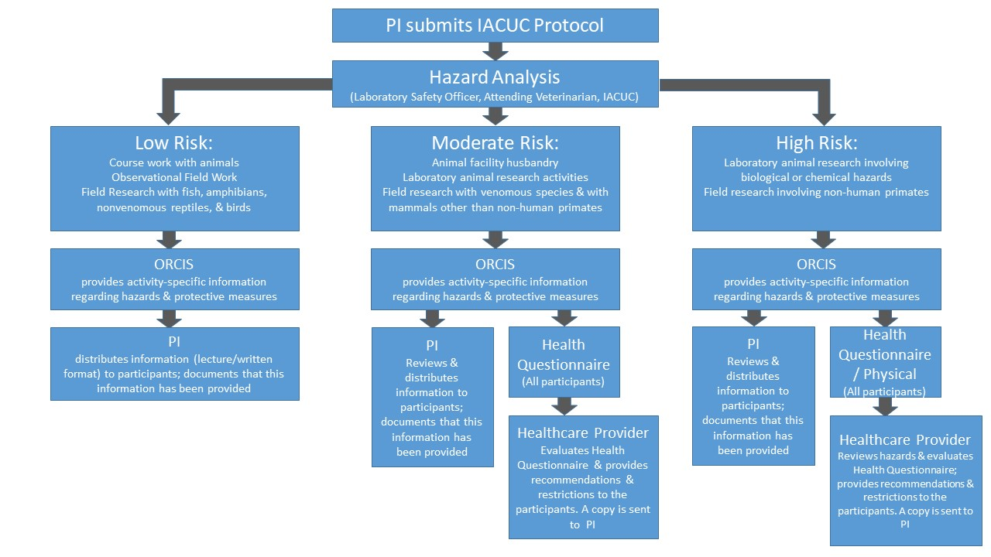
Appendix A: Process Flow Chart
Protocol
Principal Investigator(s)
Department
Species (add rows as needed) | Exposure
Does this protocol require IBC review? Yes________ No_________
Appendix B: Risk Assessment Form
If yes, list biosafety level and any biohazards:

Check activities included in protocol and their associated Hazard Level
 | Activity | Low | Medium | High
 | Physical contact with fish, amphibians, nonvenomous reptiles, or birds < 5 kg
 | Physical contact with fish, amphibians, nonvenomous reptiles, or birds > 5 kg
 | Physical contact with venomous reptiles
 | Physical contact with Animal Facility rodents or rabbits 1 day or less in any given week
 | Physical contact with Animal Facility rodents or rabbits more often than 1 day in any given week
 | Physical contact with wild rodents
 | Physical contact with wild mammals other than rodents and non-human primates
 | Physical contact with or close proximity to (within 2 m) captive or wild non-human primates
 | Work with unsterilized non-mammalian tissues, fluids, or wastes
 | Work with unsterilized mammalian tissues, fluids, or wastes
 | Work with unsterilized nonhuman primate tissues, fluids, or wastes
 | Biosafety Level 1
 | Biosafety Level 2
 | Biosafety Level 3 or 4
 | Hands-on work with mammalian bedding/cages
 | Presence in animal rooms but without physical contact with animals
 | Use of sharps (syringes, scalpels, sutures, injectors)
 | Use of volatiles (e.g., halothane) in anesthesia or euthanasia
 | Necropsy, non-mammalian species
 | Necropsy, mammals other than non-human primates
 | Necropsy, non-human primates
 | Observational field work
 | Work at accessible field sites (< 1 day’s travel to a town) for <24 hr per visit
 | Work at remote field sites (> 1 day’s travel to a town) exceeding 48 hr per visit
 | Work in a location with endemic infectious disease concerns
 | Other field risk factors (operation of all-terrain vehicles, boats, or firearms; exposure to severe cold or heat; high elevation; SCUBA)
 | Other biological or chemical risk factors (list):
 | Other risk factors (list):
Appendix C: Health Questionnaire
Overall Hazard Level: | Low |  | Medium |  | High

HEALTH QUESTIONNAIRE
Appendix C: Health Questionnaire
FOR ANIMAL PROTOCOL PARTICIPANTS

Please complete every item of the questionnaire. Please mark N/A or None as appropriate. Do not leave anything blank. The information provided in this questionnaire is strictly confidential and will not be released to Northern Illinois University or to any other agency without the explicit consent of the individual.

PARTICIPANT INFORMATION

Name: ______________________________________________ Birthdate: __________________________

Phone Number: _______________________________________

JOB INFORMATION

Job Category: Student Animal Care Worker Researcher Veterinary Admin Other

- Please list the animals with which you will be working:

___________________________________________________________________________________________________

- Please list the type of contact (if any) you’ve had in the past with these types of animals:

________________________________________________________________________________________________

- Please list any physical reactions you’ve had to animals.

HEALTH INFORMATION

- Please list the agents with which you will be working (including radiation, chemicals, cleaning products, etc.):

________________________________________________________________________________________________

- Please list the type of work you will be doing with animal (observation, handling, husbandry etc.)

________________________________________________________________________________________________

HEALTH INFORMATION

- Please list any medications that you are using:
________________________________________________________________________________________________

- Please list any medication allergies:

________________________________________________________________________________________________

- Please list any previous hospitalizations or surgeries:

________________________________________________________________________________________________

- Please list any history of chronic rhinitis or sinusitis, asthma, eczema, hives, skin rashes, tongue/throat swelling, anaphylaxis, or positive allergy testing:

________________________________________________________________________________________________

________________________________________________________________________________________________

- Please list any history of immunosuppression from medication or medical conditions. Examples include HIV/AIDS, cancer, lymphoma, myeloma, chronic steroid use organ/bone marrow transplantations, sickle cell anemia, and spleen injury.

________________________________________________________________________________________________

HEALTH QUESTIONNAIRE (continued)

- Are you currently pregnant, trying to become pregnant, or breastfeeding? Males: not applicable

________________________________________________________________________________________________

- Please list any history of heart disease, lung disease, chronic liver disease, chronic kidney disease, or spleen removal:
________________________________________________________________________________________________

- Please list any work restrictions you are currently have due to your health:

________________________________________________________________________________________________

- For workers with animal contact please list any problem lifting the cages or pushing/ pulling the platforms:

________________________________________________________________________________________________

- Do you have a known latex allergy diagnosed by a medical professional? Yes No

- Are you currently experiencing:
Unexplained fatigue, weight loss or lack of energy? | Yes | No
Unexplained fever, chills, night sweats, or lymph node enlargement? | Yes | No
Severe headaches, visual changes, hearing loss, blackouts, dizziness, weakness, or numbness? | Yes | No
Depression, anxiety, memory loss irritability, or uncontrolled temper? | Yes | No
Shortness of breath at rest or with activity? | Yes | No
Wheezing, persistent cough, sputum production, or coughing up of blood? | Yes | No
Persistent nausea, vomiting, abdominal pain, or diarrhea? | Yes | No
Rashes, hives angioedema, anaphylaxis or other allergic problems? | Yes | No
Muscle aches, tremors or weakness? | Yes | No
Swollen and painful joints? | Yes | No
Pain with bending stooping or kneeling? | Yes | No
Hearing problems or ringing in the ears? | Yes | No
Other? Please list and describe | Yes | No

If you answered “yes” to any of the above items, please provide details here. Please be as specific as possible.

________________________________________________________________________________________________

- Have you had a tuberculosis test in the last year? Yes No Results:_______________ Date: ____________ Chest XRay________

Clearance from Board of Health _____________________

- Date of last tetanus vaccine:___________________ Tdap Td

- Have you received the Rabies vaccination series? Yes No Reason for being vaccinated: Post-exposure Pre-exposure

- Please list any current or historical problems with your back/neck:

_______________________________________________________________________________________________________________

- Please list any current or historical problems with your joints (including shoulders, knees, wrists, or ankles):

______________________________________________________________________________________________________________

I have completed the above questionnaire honestly and completely. If anything changes in my health status, I will notify my supervisor immediately. (Examples: pregnancy, allergies, surgeries, immunosuppressive drugs, infectious disease, or any questions above change to yes.)

_____________________________________________________________ __________________________

Signature Date

